Article published in Business Change and Reengineering, The Journal of Corporate Transformation, April 1994

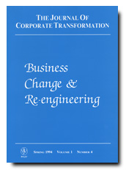
________________________________________________________________
LEARNING TO CHANGE IN SMITHKLINE BEECHAM
By Tony Coyle and Tony Page
________________________________________________________________

Autobiographical note
Tony Coyle is Human Resource Development Director, SmithKline Beecham International. He led the design in SmithKline Beecham of the trainer and facilitator training and is also responsible for the implementation of ‘Simply Better’ Way in the International Pharmaceuticals Division of SmithKline Beecham.

Tony Page, a Partner in Page Consulting, is working with Tony Coyle and others in SmithKline Beecham to introduce principles of world class training and facilitation into the implementation of ‘Simply Better’ Way. He co-designed with Tony Coyle one of the core facilitator training modules entitled “Facilitating Process Improvement”.

Abstract/management summary
The purpose of the paper is to illuminate the human dimension to learning and change that accompanied a corporate change programme in SmithKline Beecham called ‘Simply Better’ Way.

Training is an important element in any corporate change programmes but how often does training truly reinforce espoused corporate values? What learning and change is really taking place within individuals as a consequence?

The viewpoints of three individuals are explored in depth: a sponsor, a process owner and a front-line worker.

The paper demonstrates that in training the “medium is the message” and offers five “world class training principles” which help to ensure a training design effectively drives a corporate change programme.

Keywords
Learning
Change
Facilitation
Human dimension

WHY CHANGE?
SmithKline Beecham’s is one of the world’s leading healthcare companies whose principal activities are the discovery, development, manufacture and marketing of both human and animal pharmaceuticals, over-the-counter (OTC) medicines, health-related consumer brands and clinical laboratory testing services.

In February 1993, SmithKline Beecham launched itself on a major programme of change. SmithKline Beecham, at 11th position in the FTSE-100 index, with 54,000 staff in over 100 countries throughout the world, was highly profitable (1992 pre-tax profit £1.1 billion) and growing impressively (1992 sales increased 11%, pre-tax profit increased 11%, earning per share increased 14%). So why did SmithKline Beecham want to change?

The reason was simple. When towards the end of 1992, SmithKline Beecham’s Executive Management Committee took a two week study tour to Japan, they become convinced that past success was no guarantee of future success (“We’ve done well but we cannot stand still”). The company, faced with new economic and political uncertainties, healthcare reform and changing markets, had to wake up to the realities of a turbulent environment and learn to change faster than its competitors in order to get ahead and stay ahead.

THE CONTEXT FOR CHANGE
SmithKline Beecham was formed from the merger in 1989 of the US pharmaceutical company SmithKline Beckman Corporation and the British owned Beecham Group plc. It was billed as a merger of equals providing the potential of creating a new and better healthcare company. At this time critics of the merger were saying: “mergers never work”, “you cannot do a merger and maintain business momentum simultaneously”, “the merger is only about cost savings”.

The immediate priority in 1989 was to bring the two companies together under one banner with a shared future direction and some shared support systems. In the year following the merger, the company, aiming further to unite the two companies and build greater competitive awareness, embarked on an ambitious culture change programme called ‘Simply Better’ in which the new company culture of SmithKline Beecham was made explicit in the form of five values and a defined set of leadership practices. See figure 1 below.

Figure 1: FIVE ‘SIMPLY BETTER’ VALUES

CUSTOMER
INNOVATION
INTEGRITY
PEOPLE
PERFORMANCE

To what extent was integration of the two companies into the one new SmithKline Beecham company culture achieved by ‘Simply Better’? Apparently successfully, instilling in people a commitment to continuous improvement and change. Transformed management behaviour was achieved through effective performance management. For example, in the international division of the pharmaceuticals business, a new appraisal system ensured that people were assessed according to how well they performed against the ‘Simply Better’ values and practices.

In 1992, as a result of the study tour to Japan, it became apparent that the job of creating one corporate culture under ‘Simply Better’ was not yet complete. Most people did know from ‘Simply Better’ values and practices WHAT the SmithKline Beecham culture was, but not HOW to achieve improvement. There was a need to expand further the awareness of 54000 people throughout SmithKline Beecham of the need for improvement. There was a need for one corporate voice to unite the four business sectors (Animal Health, Clinical Laboratories, Consumer Healthcare and Pharmaceuticals) of SmithKline Beecham. There was a need for discipline, for standardised methods and tools and support systems with which to pursue improvement across the entire company. ‘Simply Better’ Way was born from this need.

THE CHANGE PROGRAMME
What is ‘Simply Better’ Way? It is built on and develops from ‘Simply Better’. It is a new language for use across the entire company. It includes both a new management system called an “architecture” and a common way of working. See figure 2 below.

Figure 2: WHAT IS ‘SIMPLY BETTER’ WAY?

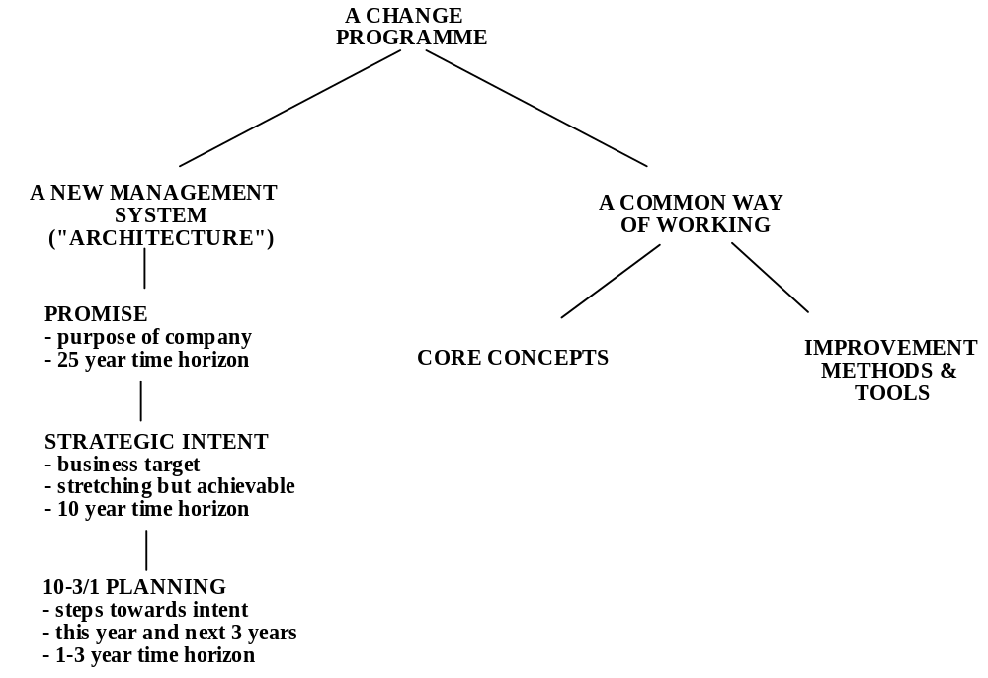

First, the “architecture” specifies how the company will achieve its chosen target over the next 25 years. The architecture starts with the “Promise”. This is purpose of SmithKline Beecham. It justifies the existence of the company and points to the value it adds to the world. It will not be achieved overnight and it might take 25 years or more to accomplish this purpose fully.

The second part of the architecture is called “Strategic Intent”. This is a stretching but achievable business target which serves to unite everyone’s efforts in a single direction over the next ten years towards the achievement of the longer term “Promise”.

The measure of whether the “Strategic Intent” has been achieved is the five ‘Simply Better’ values listed in figure 1 which have been carefully and precisely defined to provide a specific measurable target for the company.

Together the “Promise” and “Strategic Intent” are designed to help harness the collective power of everyone in the company and focus that power on the right target.

The mechanism that pulls all of the elements of the architecture or management system together is “10-3/1 Planning”. Each business unit has a 10-3/1 plan which describes what that unit needs to do this year and over the next three years to achieve the ten year target.

‘Simply Better’ Way in addition to providing a management system, also provides a common way of working, based on six simple common sense concepts backed up by powerful improvement methods, tools and techniques to build and develop everyone’s skills in problem solving and improvement. This is the ‘Simply Better’ Way of Working.

‘Simply Better’ Way has the potential to transform SmithKline Beecham over coming years into a unified learning organisation. ‘Simply Better’ Way is designed to deliver for SmithKline Beecham company-wide cultural change, a shared language, a commonly understood way of working throughout the world, total employee involvement and continuous improvement. In short, ‘Simply Better’ Way affects everyone and everything that is done in SmithKline Beecham.

BRINGING PEOPLE INTO ‘SIMPLY BETTER’ WAY
The architecture, concepts, methods and tools of ‘Simply Better’ Way looked fine on paper. The issue in early 1993 was how to breathe life into them, how to gain acceptance for them, how to bring them into daily use by 54000 across the entire world. What methods were used in SmithKline Beecham to bring people in to ‘Simply Better’ Way?

Management Conference
The first successful milestone was SmithKline Beecham’s February 1993 management conference in Florida, attended by 350 top managers from 38 countries of the world. The programme consisted of presentations, breakouts and a gala evening.

The presentations were well-prepared, the message was “we’ve done well but we cannot stand still”, there was an open and clear explanation of “why change” and strategically “what it will mean”, all members of the Executive Management Committee took turns to present an aspect of ‘Simply Better’ Way thus creating an impressive display of unanimity. “Learning by Doing” was announced as the corporate theme for 1993. The Executive Management Committee were seen as honest. They were convinced ‘Simply Better’ Way was the right route to take, but at the outset no one could see the full path. It would be necessary to be a learning organisation, experimenting, innovating and learning from mistakes.

The breakouts were very interactive providing a live demonstration of ‘Simply Better’ Way facilitation skills and techniques without any coercive expectation that people would immediately “sign on” to the ‘Simply Better’ Way programme. Breakout groups worked on issues including “the challenges of implementing ‘Simply Better’ Way”. The results from the breakouts were played back to the conference the following morning.

The gala evening provided celebration and recognition for individual, team and sector achievements. There was a dinner, prizes presented by the Chief Executive, Sector Heads reading out a list of names of high achievers who came out to shake hands with the Chief Executive. Lights and music helped to create a sense of occasion. The evening culminated in a three and a half minute video of people in SmithKline Beecham achieving great things with a Tina Turner soundtrack blasting “Simply the Best”. Spontaneously 350 managers rose to their feet clapping in time with the music, there was a great sense of being one company, bonding had taken place and expectations were being raised for the future.

The positive mood at the conference was fuelled by the positive recognition of achievements to date, the merger was taken to be totally successful and complete, the past was put behind and interest was moving outwards into how to maintain and build competitive advantage for SmithKline Beecham.

Following the conference, the 350 top managers were given lots of ways to get involved through attending training, sponsoring and participating in improvement projects, selecting their most able people to be trained as facilitators.

Trainer and Facilitator Education
During the period April to December 1993, over 1300 people received ‘Simply Better’ Way education: 550 Sponsors who drive ‘Simply Better’ Way in each company unit, 20 Coach-trainers who trained 140 Country/Site/Unit Trainers who trained 650 Facilitators in ‘Simply Better’ Way methods and tools. The Facilitators then went on to who train and help Sponsors, Process Owners and Team Members to set up and run process improvement teams. More than 500 starter projects were initiated. See Figures 3 and 4.

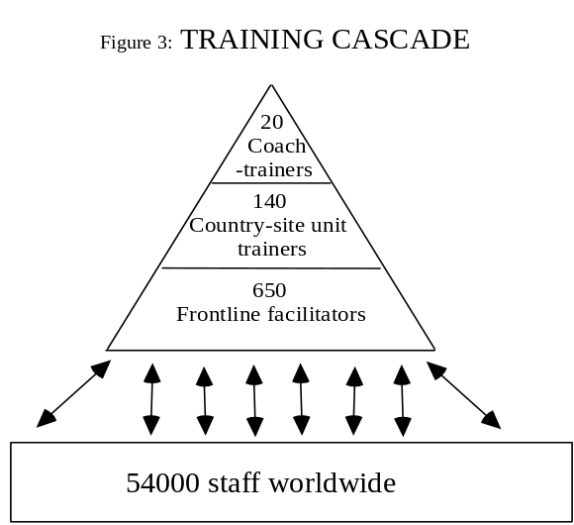

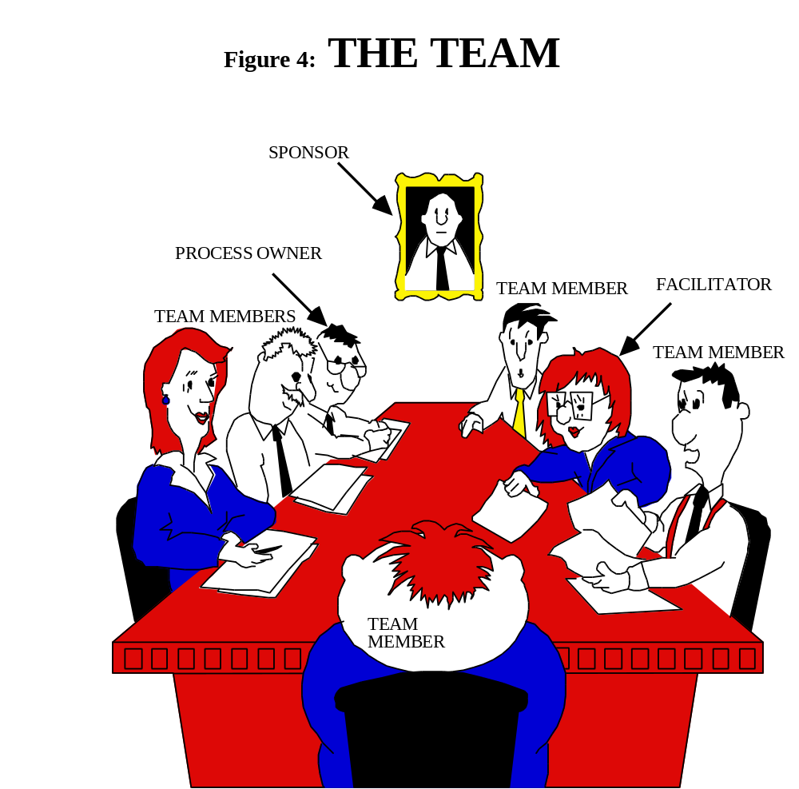

The education was designed in accordance with five “world class training principles” which serve to maximise learning and change in the individual participant and to model a style of involvement intended to be used by trainers and facilitators as ‘Simply Better’ Way unfolds:

1.The OBJECTIVE is to improve performance in the role
Trainer classroom behaviour: describe, explain, demonstrate and model successful performance as a facilitator, encourage participants to practise and develop their skills, explain the method for self-assessment and development planning

2. The CONTENT is real-life exercises in pairs and teams not abstract knowledge or theory
Trainer classroom behaviour: devote the bulk of time to participant work in small teams of 4 or 5 people using exercises based on a relevant case example, debrief and discuss learning points in class

3. The STYLE is facilitative, experiential, collaborative, involving, multi-dimensional, exploratory and engaging not one-way, instructional, presentational or one dimensional
Trainer classroom behaviour: encourage participants to reflect on experience gained in small group work, use questioning in the classroom to engage the group in the learning process, uncover concerns, allow learning points to emerge from participants concerns and insights.

4. The RESPONSIBILITY for learning, decision-making and action is with the individual participant supported by colleagues and course leaders
Trainer classroom behaviour: ask participants to define and share their personal learning objectives in class, have regular “ponder” sessions in which participants reflect and report on their own learning and plans for application

5. RESISTANCE is surfaced and dealt with openly and directly not buried or ignored.
Trainer classroom behaviour: when trainer senses resistance, question and probe to uncover participant’s difficulty (eg. tired? confused? overloaded? sceptical? etc), summarise and playback to the class what is uncovered, ask participants to suggest a means to overcome the difficulty, assume participants are responsible and share your objectives, respond flexibly and act on the suggestion or negotiate to overcome problem, ensure participant remains engaged in the group learning process.
See figure 5.

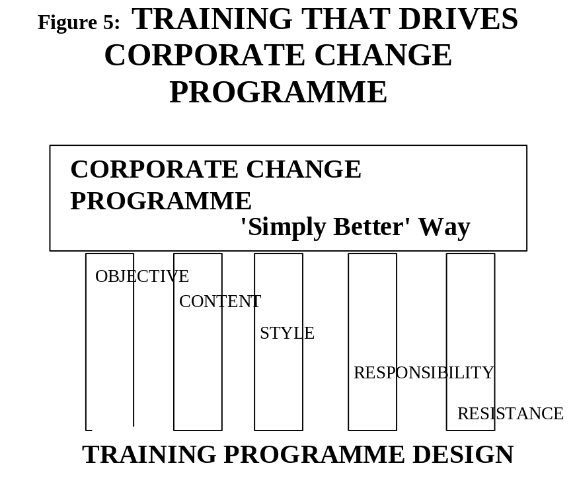

MEANWHILE, BACK AT THE WORKPLACE....
The reality of ‘Simply Better’ Way is not at the conference, or in the classroom, but back in the workplace. During 1993 a large number of interviews and meetings at which the question of workplace response to ‘Simply Better’ Way was discussed.
The three vignettes which follow represent disguised representative viewpoints distilled from the many discussions. They aim to tell the story of ‘Simply Better’ Way through the eyes of three people who were directly involved in it: a Sponsor, a Process Owner and a telephonist in a front-line service role. They portray how company wide change, designed to involve 54,000 people throughout the world, was actually experienced by three individuals in SmithKline Beecham.

The “Sponsor’s” Viewpoint
Lionel Brown, is the Factory Manager at one of SmithKline Beecham’s UK-based pharmaceuticals manufacturing plants. He has been in this role for four and a half years and has worked for the company in total for 25 years since gaining his PhD. During his time with the company his promotion has been rapid. Apart from a few brief visits abroad for meetings he has always been based in the UK. He is 52 years old, married, comfortably well-off and his two sons are both at university.

When did I first become involved in Simply Better Way? I did not attend the Florida conference but I soon heard about it: my boss, Roger, came back fired up. I haven’t seen him charged like that since three years ago he returned from a head office meeting with plans to build a new factory on our site. I naturally felt wary of what to expect. The worst thing about it was the fear of the unknown, of having my ideas of “the world as we know it” re-configured to suit a new management fad.

My first direct involvement in Simply Better Way was in an event called Leadership Forum which was attended by hundreds of senior managers in SmithKline Beecham. It was held in Brighton, England and lasted three and a half days. We all had a lot of fun and got to know colleagues from other parts of SmithKline Beecham for the first time.

During the Forum I began to get the flavour of ‘Simply Better’ Way and understood that it is my role to drive it. I was heartened to learn that ‘Simply Better’ Way is actually about our work itself rather than the vague concepts, values and hard-to-apply principles we have had in the past.

What happened next? It was June and half way through the year. I felt a real urgency to get on with ‘Simply Better’ Way. I wanted to get started with some improvement projects in the factory. The bad news was I needed a facilitator before I could start a project. The person I had previously nominated as facilitator, had not yet been trained. We had to wait for a space on a corporate run course.

Training took time. Each facilitator had to go through three separate courses in total equating to ten working days of training.

How effective was the training? When the facilitator arrived I must admit to being impressed. The training was not actually run by a corporate faculty and was not run by external consultants either. It had been delivered by our own people and this helped our people to relate to it.

All the facilitators I have met are full of energy, enthusiasm and commitment. It is as if they are thrilled to have been chosen for the role.

What is more important they seem to know what they are talking about. I do not always agree with them and (this is rather unusual as I am the boss) they do not always agree with me. They know a lot more about the improvement methods and tools than I do which is both reassuring and unsettling for me. They have had detailed training which is good. Now I want to go on the same training myself.

How far have we got with ‘Simply Better’ Way? We have kicked off our Starter Project now which is a “learning piece” and I am more interested in what we learn about the ‘Simply Better’ Way methods and tools than in the result.

Normally on an improvement project I will be outside it as “Sponsor” but for the first one I am getting directly involved. I like this because I can get to know the detail of the method and see how my people are affected by it. I am concerned that because of my position, I might be inhibiting the others a little bit so I keep my mouth shut a lot of the time and leave it to the facilitator.

How do I see the future of ‘Simply Better’ Way? The buzz on the grapevine is good. I expected to be faced with more cynicism and resistance from the die-hards who have worked in the factory for year after year. For these people there is a lot of change to take on board. If it was unsettling at first for me, it must be much worse for them.

I expect there are still some difficulties ahead. I am concerned that as a company we are rushing at it very fast, but so far we have not tripped up and the momentum seems to be carrying everyone along with it. The communication events that we ran involved literally everyone, so perhaps that helped.

Now I’m looking forward to the results of the starter projects. Privately, I am desperate to use the methods and tools on some of our more critical processes and generate some worthwhile results which might help to justify all of this effort so far.

The “Process Owner’s” Viewpoint
Melanie is the production manager in one of the SmithKline Beecham factories that produces Lucozade. She was recruited by SmithKline Beecham 10 years ago direct from her production engineering course at university. Melanie is 32 years old, married.

When did I first become involved in Simply Better Way? After everyone else I think. First the Factory Manager went away to a course in Brighton and returned keen to get something started but none of us were sure quite what it was!

One of my people got nominated to be a facilitator. We had to let them go and we picked up the pieces doing their job while they went away for weeks at a time to get trained. I felt that here I was with a factory to run while everyone else was going loopy about ‘Simply Better’ Way!

At this point I did not even know what ‘Simply Better’ Way was. Everything everyone told me sounded like a lot of Japanese management jargon. To me ‘Simply Better’ Way was a lot of incoherent nonsense. At times I wondered if SmithKline Beecham had been somehow duped by some clever consultants!

‘Simply Better’ Way really was a real turn-off as far as I was concerned. There seemed to be an “in-crowd” and an “out-crowd” and I was definitely in the “out-crowd”. I was surprised how uncomfortable I found this and if I have learned anything from ‘Simply Better’ Way so far, it is not to allow anyone else to feel they are outside of it. Being outside ‘Simply Better’ Way is painful, disturbing and disruptive.

What happened next? It started getting better. There was a management workshop at which we planned how to introduce ‘Simply Better’ Way in our own area. The materials and pre-reading were very well put together and I felt I finally knew what we were talking about here.

It was part of my job as production manager to run communication events to inform all of our staff about ‘Simply Better’ Way. These events each took a day and I was pleased now to be in a positive role with ‘Simply Better’ Way: bringing people in to it, including them and explaining to them how ‘Simply Better’ Way will affect what we are doing in the factory.

How effective was the training? I do not know because I have not been included on any courses myself. If you are talking about the management workshop and the communication events, then I would say these have been well-designed and were effective, but that was really up to us wasn’t it?

The facilitators have been well trained, they seem to know their stuff and have been most helpful to me.

How far have we got with ‘Simply Better’ Way? I am involved as a Team Member on our Starter Project. More usually I might expect to be in the Process Owner role but for the first project the boss is taking that role. Being a Team Member gives me a chance to experience the methods and tools in a low risk way, learning them as we go along.

I’m feeling a lot more positive now and I can see how ‘Simply Better’ Way is of value to SmithKline Beecham.

How do I see the future of ‘Simply Better’ Way? It is going to become unstoppable. In fact it already is. I have nailed my colours to the mast as a supporter of ‘Simply Better’ Way by delivering the communication events to all my staff. I cannot go backwards now, I have to make sure that it works and I believe that it will.

There is nothing strange or different about ‘Simply Better’ Way any more. It is accepted as good plain common sense. Certainly we have plenty more to learn about it, but now no one is afraid of ‘Simply Better’ Way.

The Starter Project is not complete yet, but I do not even think that matters now. Gradually ‘Simply Better’ Way is becoming part of the way we think, talk and behave in the factory.

The “Front-line” Viewpoint
Emily is 21 years old. She works as a clerk/telephonist in a SmithKline Beecham clinical laboratory in the US. She has worked for SmithKline Beecham for around 18 months.

When did I first become involved in Simply Better Way? Not for a long time. I noticed people referring to ‘Simply Better’ Way more than 6 months ago. You pick things up you know in this job. You notice if people are walking around with frowns on their faces. You find out what people are having arguments about. We chat about it in the toilets and over lunch. I had started to see ‘Simply Better’ Way on the agendas of the management meetings. When people leave telephone messages you start to notice it is “‘Simply Better’ Way this” and “‘Simply Better’ Way that”.

I began to wonder when someone would tell me what ‘Simply Better’ Way was.

What happened next? I did not become involved in it until the big meeting we had. I got invited to the meeting. We all did. It lasted all day. It was called an “event”. I was wondering what kind of thing it would be. I did not know what to think. We were chatting about what was going to happen. We wondered why couldn’t they just tell us what it was in the usual way.

We went to a local hotel because we did not have a room big enough at the lab. The room was all decorated with posters. The best thing was the sound system. Tina Turner was blasting out SIMPLY THE BEST! It was good. I got interested. Everyone got really involved. It all made sense. It told us about the company we were part of and where the company was heading.

We were still a bit worried. Why was the company spending all this money? What were they going to get back for it? But I am not as worried now as I was.

We spent a long time doing exercises to learn about the core concepts of ‘Simply Better’ Way. I really did feel I understood it. It’s common sense really. The company has competitors and we want to beat them, but the game is changing so fast so we have to keep improving. We all need to be involved in making improvements, it is no good leaving things to someone else to improve.

How effective was the training? It wasn’t really training like in a class room or like when I was training to be a telephonist. It was more to do with discussing things, having our say, giving our ideas. It felt good to be asked. I felt that the company was really interested. But I don’t know how effective it was really. It must have cost a lot of money. We were all being paid to sit around talking for a day.

How far have I got with ‘Simply Better’ Way? Since the event I’ve noticed some new activities going on around me. The meeting room is always booked up for team meetings. On the wall outside the meeting room is a big display called a “Storyboard”. It tells the story of the project the team is working on.

When you read the faces, there is still the same mixture of expressions: some happy, some worried, some tense and some stressed out.

I feel a little bit more included. If I see something that is wrong or could be better I feel that it is worth pointing out now. I know I could find someone who will listen.

How do I see the future of ‘Simply Better’ Way? As long as we’re all still involved I think ‘Simply Better’ Way really does have a future. I want to get in on a team one day and see what really is going on in the meeting room.

I’m going to go along to the training sessions. I don’t think everyone will. Some people are just negative, they will moan about whatever you give to them.

With the outside world bleak as it is, I would rather work for a company that is going to beat the competition than one that is about to get beaten. If I can play a part in making our company the best, I’ll do it.

BENEFITS ACHIEVED
Each Coach Trainer trained seven Country/Site/Unit Trainers who each trained seven Front-line Facilitators. So far 650 Facilitators have been trained in SmithKline Beecham and their ratings of the training provided have been excellent (4+ on a 5 point scale where 5 is the top score ). Facilitators are currently working on Starter Projects each with a Sponsor and a Process Owner and a number of Team Members.

Steadily during 1993 ‘Simply Better’ Way extended itself from a set of ideas in a manual into a language used by thousands of people throughout the company, a method applied in teams in the workplace to drive change. With the new language and methods has arrived a new attitude that seeks improvement, learning and change that is starting to replace an older, deep-rooted and quite widespread change-averse attitude.

It is too early to assess bottom-line benefits gained or to weigh these against the costs of the programme. The company results for 1993 despite turbulence continued the trend established during the five years since the merger (pre-tax profit £1.22 billion, sales increased 18%, pre-tax profit increased 12%, earnings per share rose 15%). We do not yet have all 54000 directly involved in ‘Simply Better’ Way, but we expect to by the end of 1995. Facilitators do not yet all feel totally confident with their new skills set. What is apparent to those working with Facilitators is the high level of knowledge, commitment and enthusiasm they demonstrate.

LESSONS LEARNED
The three individual viewpoints presented here underline how change really happens: each individual “buys in”. Each individual who has “bought in” brings more people in with them.

For all training activity, the “medium is the message”. Trainers and facilitators are role models for ‘Simply Better’ Way. The words expressed by the trainer are rather less important than their non-verbal behaviour and their belief in ‘Simply Better’ Way. See figure 6.

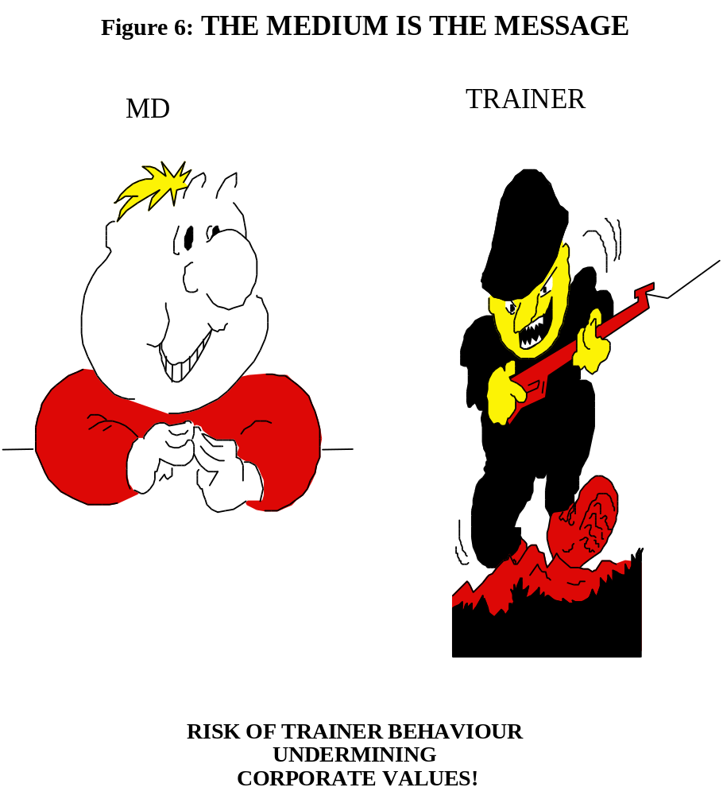

Authentic behaviour by the trainer or facilitator translates directly into belief and buy-in to ‘Simply Better’ Way. This is what creates a multiplier effect (rather than a dilution) as the training cascades out to 54000 people. The five principles for World class training served to create a medium which underpins ‘Simply Better’ values and reinforces the “buying in” by each individual to ‘Simply Better’ Way and drives the corporate change programme.

Is well-designed training sufficient to achieve “buy-in” to a programme of change? No. Other factors are clearly important too including:
• having clearly defined roles (Sponsor, Coach-Trainer, Facilitator, and so on)
Why? Change can be confusing and disorienting. Defined roles provide a sense of certainty, a clear job role and level of performance for individuals to work towards

• giving real responsibility out (eg. to Coach Trainers, to Country/Site/Unit Trainers and to Facilitators)
Why? This requires decision-taking by individuals which in turn triggers active thinking, engagement, and commitment to a programme of change

• providing the right kind of support (eg. practical methods and tools, training to use them, a new infrastructure)
Why? ‘Simply Better’ Way added practical support to the ‘Simply Better’ values and practices in the form of methods and tools, a major education programme and infrastructure in the form of Facilitator, Country/Site/Unit Trainer and Coach Trainer roles. Each facilitator is in a support network headed by a Country/Site/Unit Trainer who in turn is linked in to a Coach Trainer. Our experience is that where the individuals are making positive and deliberate use of these networks, the best results are being achieved. Without support from the network, the facilitator can feel isolated and ineffective. This is where scepticism about the overall programme could begin to set in.

What would we do differently next time? Provide training for middle managers correctly timed so that the Process Owner population consider themselves fully part of the programme. Their training would teach them about the change process they are in and how to manage change. We expect that this would help them as individuals by reducing stress, creating a feeling of support from their colleagues, converting them from resistors into positive agents for change and thereby accelerating company-wide change, improvement and learning.

CHANGE HAPPENS IN UNITS OF ONE
In conclusion, ‘Simply Better’ Way is launched and taking root. Thousands more people are due to receive training this year and next. The mood of the 1994 management conference was different, more relaxed but still alert to future challenges, less emotion around ‘Simply Better’ Way, a symbolic shift away from a centralised drive towards sector-based decisions about the pace of implementation. This is seen as a measure of the maturity of the ‘Simply Better’ Way programme.

Measures and feedback channels are being installed in 1994 to enable continuous improvement of the training, the methods and tools and the programme as a whole. The ‘Simply Better’ Way programme is becoming integrated as distinctive and yet a normal and accepted day to day way of doing business.

In summary, what distinguishes the ‘Simply Better’ Way programme from so many other corporate change programmes is the recognition of the importance of the individual and the belief that change happens not to whole organisations at a stroke but within individuals, in units of one.

____________________________________________________________

